# CELL STRUCTURE AND ORGANIZATION

The Cell is a *basic unit* of *structure* and *function* of life.

* All living things are composed of cells which carry out the process that make the organism lives entity.
* All cells are basically the same in chemical composition. All life processes take place in the cells.
* Some organisms are made up of many cells and are called multicellular organisms e.g. man, pine tree, locust. Others have one cell e.g. Amoeba, they are called unicellular organisms.
* All cells are microscopic, its membrane bound it has structures that are site for chemical reaction called organism.
* They have ability to replicate, since they contain the genetic materials. So these are characteristics of cell.

## TYPES OF CELLS

There are two basic types of cells

* Prokaryotic cells
* Eukaryotic cells

Prokaryotic cells are found in organisms which do not have membrane bound organelles, they do not have nucleus.

Prokaryotes are mostly single celled organisms such as bacteria and blue green bacteria.

Eukaryotic cells are cells which have a membrane bound nucleus. They contain specialized membrane bound organelles

Eukaryotic cells can be found in a single celled organism such as Amoeba or they can be found in multicellular organisms.

## ANIMAL AND PLANT CELLS

Both animals and plants differ in structure and function in order to be able to meet the requirements of each organism.

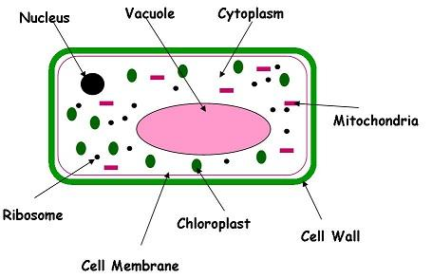

Plant cell  
  
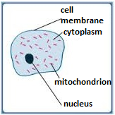

Animal cell

FUNCTION OF THE PARTS OF ANIMAL CELL  
         1. CELL MEMBRANE

* Is also known as plasma membrane or plasma lemma.
* Is thin layer that encloses the whole cell

#### Function of cell membrane

* Communicate with other cells.
* It allows selective movement of substances into and out of the cell. It is said to be a selectively permeable membrane or differential membrane
* It encloses the contents of the cell.

2. CYTOPLASM

This is jelly- like substance made up of water and dissolved chemical substances. The cytoplasm is the site for many chemical reactions in the cell. Cell organelles such as the vacuoles, nucleus and mitochondria are suspended in the cytoplasm. The movement of cytoplasm is known as cytoplasmic stream.

3. NUCLEUS

This is a round or oval organelle suspended in the cytoplasm. The nucleus is made up of nucleolus and fluid called nucleoplasm. It is surrounded by a membrane called the nuclear membrane.

#### Functions of nucleus

* To determine the chemical processes that take place in the cell.
* To control the functions of all parts of the cell
* To determine the cell size, shape and function
* To determine the hereditary characteristic of a cell

4. MITOCHONDRION

The function of mitochondrion is the site for respiration, reactions which yield energy for the cell.

## FUNCTION OF THE PARTS OF PLANT CELL

### 1. CELL WALL

* This is a strong covering made of cellulose.
* The cell wall is fully permeable. It allows the passage of water and minerals, gases (freely permeable).
* Protects and gives the cell a definite shape

2. CHLOROPLAST

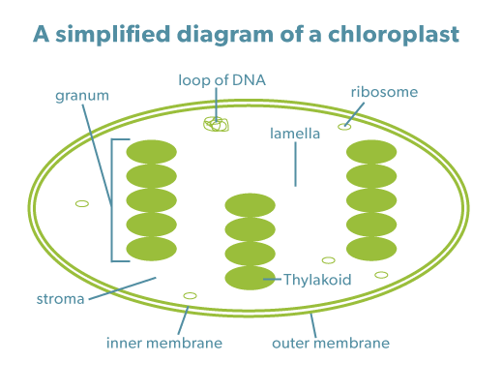

* They are sites of photosynthesis
* It contains green pigment called chlorophyll.
* Chlorophyll absorbs the light energy needed for photosynthesis

3. VACUOLE

Vacuoles maintain a balance between water molecules and solute molecules in the cell; contain colour pigments, which give colour to flower.

The fluid inside vacuole is known as cell sap.

4. MITOCHONDRIA

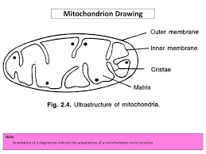

The function of mitochondria is the site for respiration, reactions which yield energy for the cell.

5. NUCLEUS

This is a round or oval organelle suspended in the cytoplasm. The nucleus is made up of nucleolus and fluid called nucleoplasm. It’s surrounded by a membrane called the nuclear membrane.

6. CYTOPLASM

This is jelly like substance made up of water and dissolved chemical substances. The cytoplasm is the site for many chemical reactions in the cell. Cell organelles such as the vacuoles, nucleus and mitochondria are suspended in the cytoplasm. The movement of cytoplasm is known as cytoplasmic stream.

7. RIBOSOMES

   This is the site of protein synthesis.

### SIMILARITIES BETWEEN PLANT AND ANIMAL CELL

* Both have cell membrane.
* Both have cytoplasm.
* Both have nucleus.
* Both have vacuoles, ribosomes and mitochondria.

### Differences between plant cell and animal cell

|  |  |
| --- | --- |
| **Plant cell** | **Animal cell** |
| Has a cell wall | No cell wall |
| Has chloroplast | Lacks chloroplast |
| Have definite shape | Have no definite shape |
| Has a large permanent vacuole | Has small temporary vacuole |
| They are normally large | They are usually smaller |
| Nucleus is peripherally located | Nucleus is centrally located |
| They store oil, proteins, starch | They store fats and glycogen |

## CELL DIFFERENTIATION

* Cells have different functions and features that make them better suited to carry out these functions. This is called cell differentiation.
* Most living things are made up of many structurally and physiologically adapted different kinds of cells.
* These cells perform specific function and this is referred to as cell specialization.
* Cell differentiation refers to the way cells are adapted so that they can carry out function efficiently.

### TISSUE

A tissue is a group of similar cells performing the same function. Basically there are two types of tissue.

Animal tissue e.g. epithelial tissue, muscular tissue, blood tissue, nerve tissue, skin tissue.

Plant tissue e.g. meristematic tissue, parenchyma tissue, collenchyma tissue, vascular tissue (xylem tissue, phloem tissue).

### ORGAN

An organ is a functional unit formed by a group of specialized tissue.

Animal organ: - heart, kidney, liver, brain, tang, stomach

Plant organ: - roots, leavers, flower, stem

### SYSTEM

System is made up of organs that work together to perform a certain function.

Examples of system are Respiratory system, digestive system, reproductive system, hormonal system, skeletal system and blood circulatory system, nervous system.

### ORGANISM

An organism is the individual living organism e.g. Animal and Plant.

An organism is made up of different systems working together specific functions

#### In Summary: **C:\thlb\cr\tz\__i__images__i__\img141.jpg**

Examples of Specialized tissues in Plants and Animals:

* White blood cells. They can change their shapes so as to engulf and destroy harmful micro-organisms.

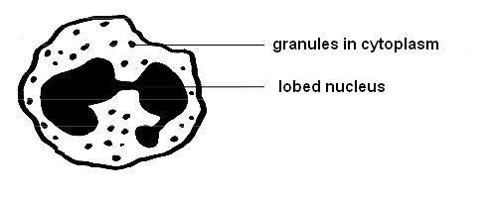

* Red blood cells. They are biconcave and lack a nucleus. They have large surface area for transporting oxygen from lungs to different parts of the body. They also contain haemoglobin which carries oxygen during transportation

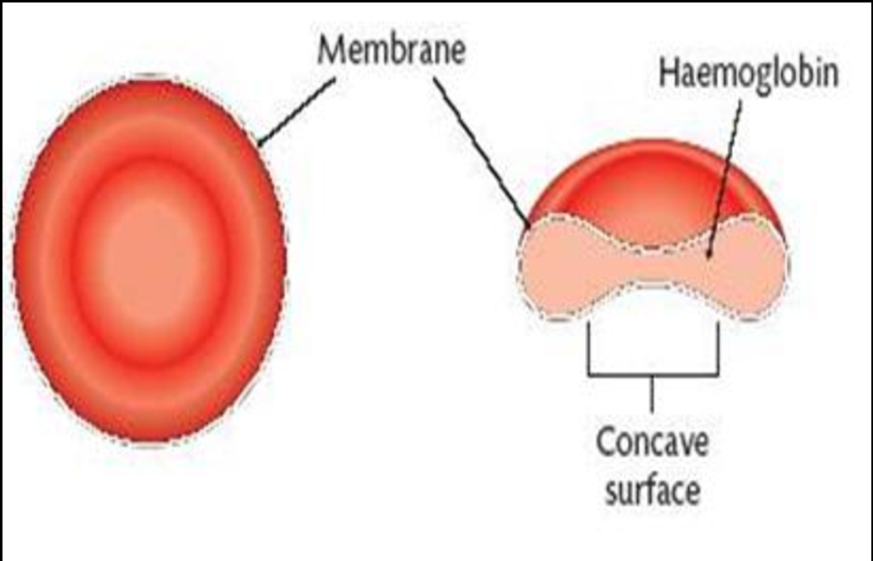

* Sperm cells. This is a male gamete which fertilizes a female gamete during reproduction. It has a tail which enables it to swim to the egg and pointed head which enables it to penetrate the egg.

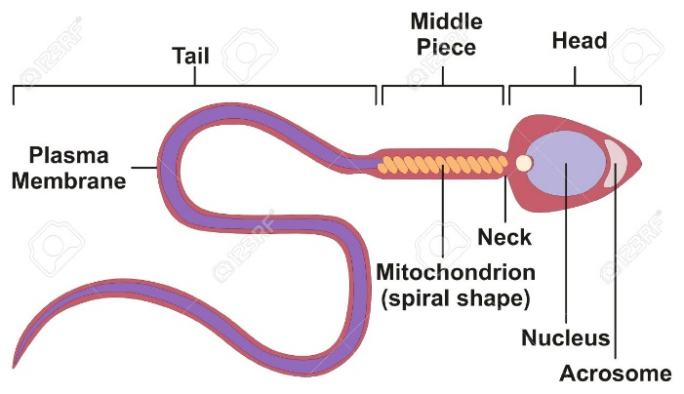

* Root hair cell. They absorb water and mineral salts in plants from the soil.

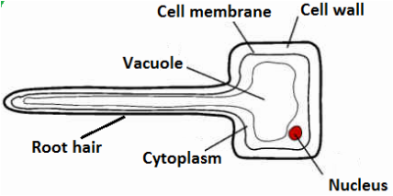

* Guard cells. Their inner walls are thicker than the outer walls. They control the opening and closing of the stomata. That is, when they expand, the stomata opens and when they contract, the stomata closes. The stomata allows gaseous exchange and transpiration in plant leaves.

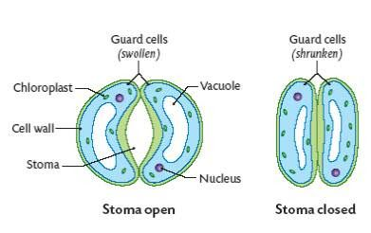

* Xylem vessels. They are made up of hollow dead cells with walls made up of lignin. The cells are connected to form xylem vessels. The vessels transport water and mineral salts, and provide support in plants.

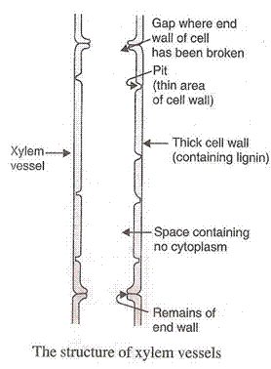

* Palisade cells. Contain large amount of chloroplast for photosynthesis.

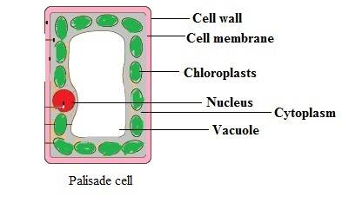

Importance of Cell Differentiation

* It leads to division of labour among cells
* It brings about efficiency in performing functions of the body
* It brings about development of the body of an organism of a particular species.